Name: AMRITANSH ANAND Reg. No.: 20BCE1650 Date: 13/08/22

**EX:3 IWP-CSS**

Design a website for “Tiger Conservation” in Asian countries using HTML and CSS.

Note:

1. Use tables, all types of hyperlinks, client-side image mapping and other tags
2. Use all 3 types of CSS and all types of CSS selectors

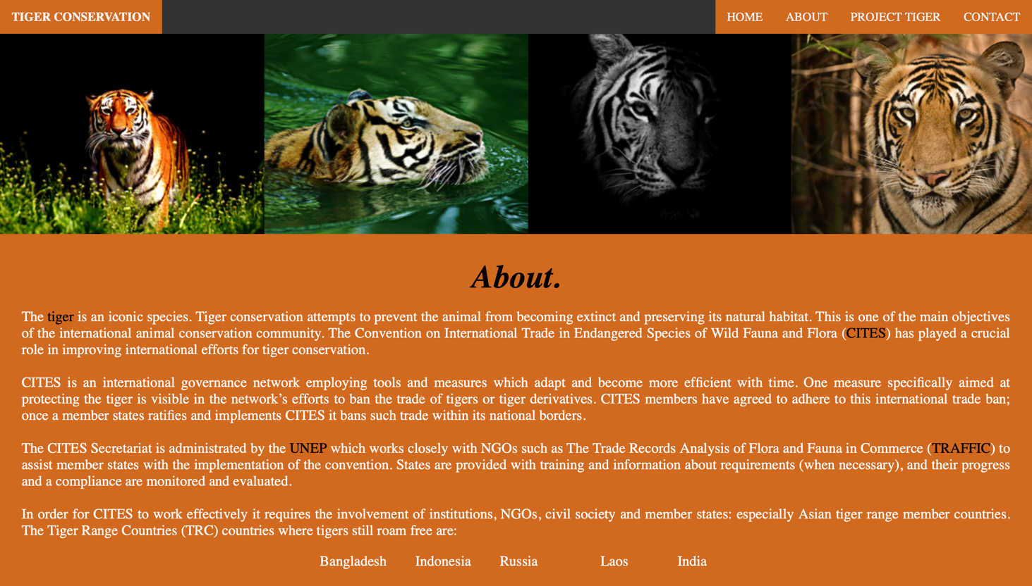

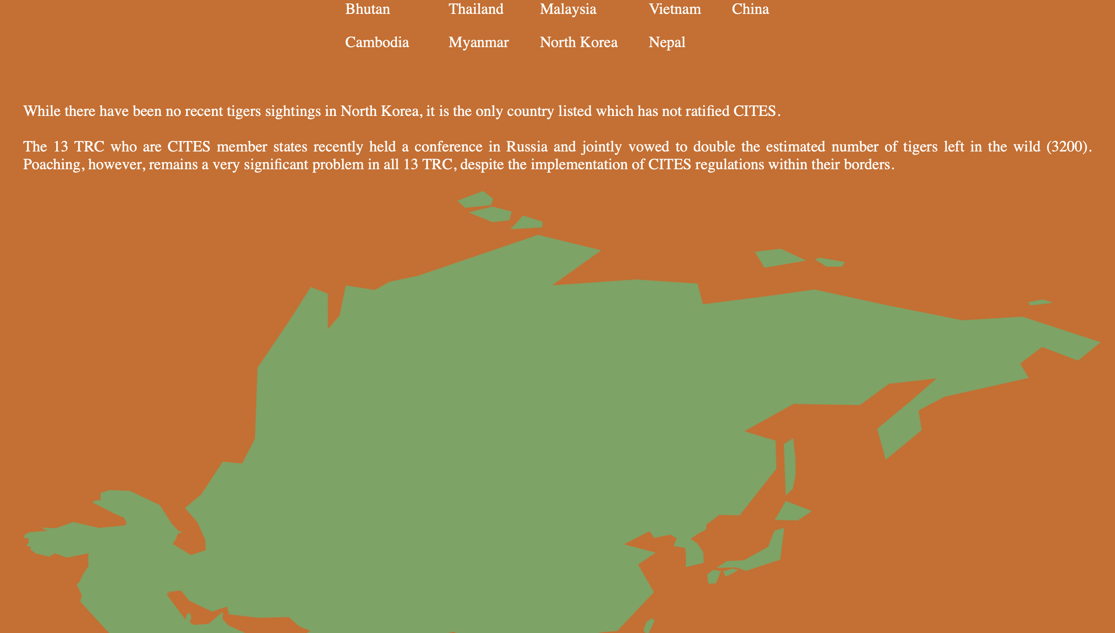

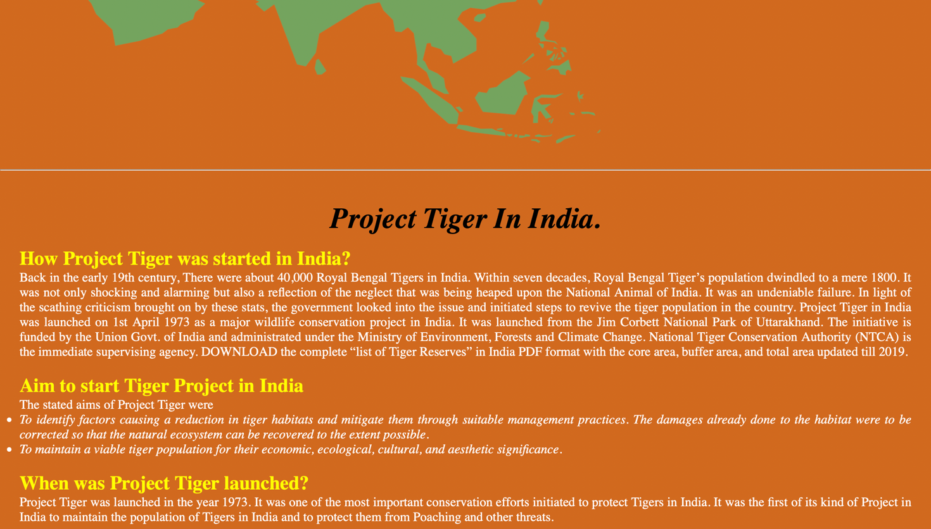

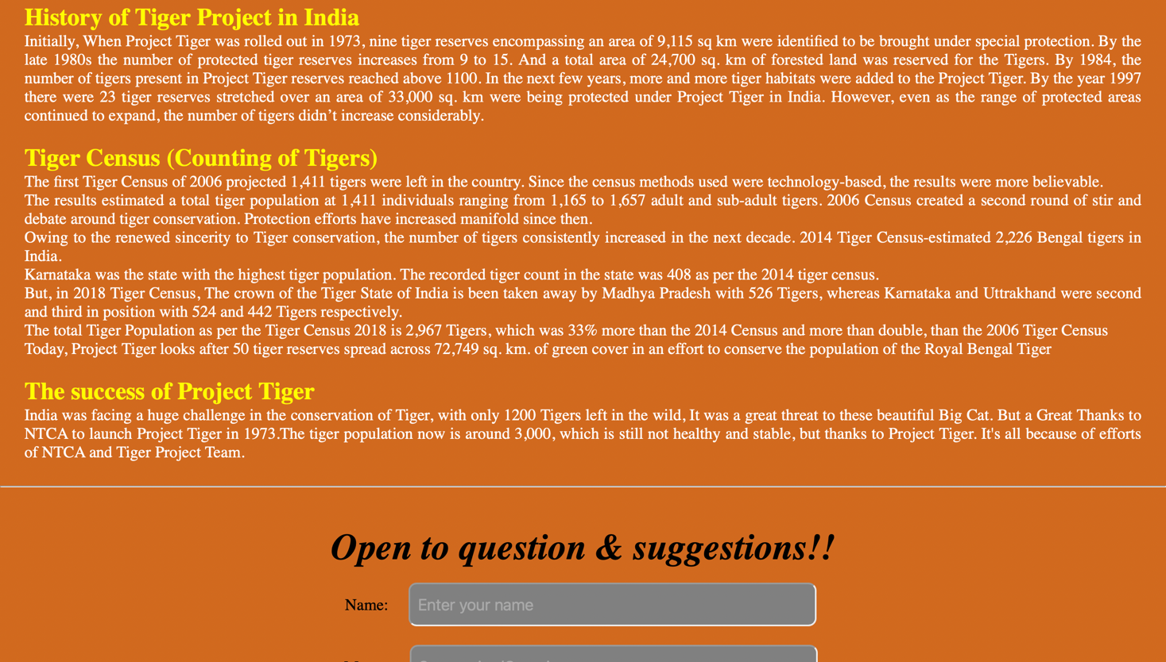



***index.html***

<!DOCTYPE html>

<html lang="en">

<head>

<meta charset="UTF-8">

<meta http-equiv="X-UA-Compatible" content="IE=edge">

<meta name="viewport" content="width=device-width, initial-scale=1.0">

<link rel="stylesheet" href="style.css">

<title>Tiger Conservation</title>

<style>

div{

font-size: 20px;

}

p{

color: white;

}

#mp{

text-align: center;

font-style: italic;

}

.center {

color: yellow;

}

ul{

color: white;

font-style: italic;

}

a{

color: black;

text-decoration: none;

}

</style>

</head>

<body>

<nav>

<div class="amritnav">

<span><a href="index.html"><B>TIGER CONSERVATION</B></a></span>

<a href="#contact">CONTACT</a>

<a href="#projects">PROJECT TIGER</a>

<a href="#about">ABOUT</a>

<a href="#home">HOME</a>

</div>

</nav>

<section id="home"><img src="mainpic.png"></section>

<section id="about" style="margin: 30px;">

<div style="font-size: 45px; font-weight: bold;" id="mp">About.</div>

<br>

<div style="text-align: justify;">

<p>The <a href="https://en.wikipedia.org/wiki/Tiger">tiger</a> is an iconic species. Tiger conservation attempts to prevent the animal from becoming extinct and preserving its natural habitat. This is one of the main objectives of the international animal conservation community. The Convention on International Trade in Endangered Species of Wild Fauna and Flora (<a href="https://en.wikipedia.org/wiki/CITES">CITES</a>) has played a crucial role in improving international efforts for tiger conservation.</p><br>

<p>CITES is an international governance network employing tools and measures which adapt and become more efficient with time. One measure specifically aimed at protecting the tiger is visible in the network’s efforts to ban the trade of tigers or tiger derivatives. CITES members have agreed to adhere to this international trade ban; once a member states ratifies and implements CITES it bans such trade within its national borders.</p><br>

<p>The CITES Secretariat is administrated by the <a href="https://en.wikipedia.org/wiki/United_Nations_Environment_Programme">UNEP</a> which works closely with NGOs such as The Trade Records Analysis of Flora and Fauna in Commerce (<a href="https://en.wikipedia.org/wiki/Traffic_(conservation_programme)">TRAFFIC</a>) to assist member states with the implementation of the convention. States are provided with training and information about requirements (when necessary), and their progress and a compliance are monitored and evaluated.</p><br>

<p>In order for CITES to work effectively it requires the involvement of institutions, NGOs, civil society and member states: especially Asian tiger range member countries. The Tiger Range Countries (TRC) countries where tigers still roam free are:

<table cellspacing="20" style="color: white;">

<tr>

<td>Bangladesh</td><td></td><td>Indonesia</td><td></td><td>Russia</td><td></td><td>Laos</td><td></td><td>India</td>

</tr>

<tr>

<td>Bhutan</td><td></td><td>Thailand</td><td></td><td>Malaysia</td><td></td><td>Vietnam</td><td></td><td>China</td>

</tr>

<tr>

<td>Cambodia</td><td></td><td>Myanmar</td><td></td><td>North Korea</td><td></td><td>Nepal</td>

</tr>

</table>

</p><br><br>

<p>While there have been no recent tigers sightings in North Korea, it is the only country listed which has not ratified CITES.</p><br>

<p>The 13 TRC who are CITES member states recently held a conference in Russia and jointly vowed to double the estimated number of tigers left in the wild (3200). Poaching, however, remains a very significant problem in all 13 TRC, despite the implementation of CITES regulations within their borders.</p><br>

</div>

<center><img src="asia.png" alt="Workplace" usemap="#workmap" height="795px" width="1393px"></center>

<map name="workmap">

<area shape="rect" coords="404,666,453,163" alt="india" href="https://en.wikipedia.org/wiki/Tiger_reserves_of_India">

<area shape="rect" coords="322,1150,727,445" alt="china" href="https://en.wikipedia.org/wiki/South_China_tiger">

</map>

</section>

<hr>

<section style="margin: 30px;" id="projects">

<br>

<div style="font-size: 45px; font-weight: bold;" id="mp">Project Tiger In India.</div>

<br>

<div style="text-align: justify;">

<h1 class="center">How Project Tiger was started in India?</h1>

<p>Back in the early 19th century, There were about 40,000 Royal Bengal Tigers in India. Within seven decades, Royal Bengal Tiger’s population dwindled to a mere 1800. It was not only shocking and alarming but also a reflection of the neglect that was being heaped upon the National Animal of India. It was an undeniable failure. In light of the scathing criticism brought on by these stats, the government looked into the issue and initiated steps to revive the tiger population in the country. Project Tiger in India was launched on 1st April 1973 as a major wildlife conservation project in India. It was launched from the Jim Corbett National Park of Uttarakhand. The initiative is funded by the Union Govt. of India and administrated under the Ministry of Environment, Forests and Climate Change. National Tiger Conservation Authority (NTCA) is the immediate supervising agency. DOWNLOAD the complete “list of Tiger Reserves” in India PDF format with the core area, buffer area, and total area updated till 2019.</p>

<br>

<h1 class="center">Aim to start Tiger Project in India</h1>

<p>The stated aims of Project Tiger were

<ul>

<li>To identify factors causing a reduction in tiger habitats and mitigate them through suitable management practices. The damages already done to the habitat were to be corrected so that the natural ecosystem can be recovered to the extent possible.</li>

<li>To maintain a viable tiger population for their economic, ecological, cultural, and aesthetic significance.</li>

</ul>

</p>

<br>

<h1 class="center">When was Project Tiger launched?</h1>

<p>Project Tiger was launched in the year 1973. It was one of the most important conservation efforts initiated to protect Tigers in India. It was the first of its kind of Project in India to maintain the population of Tigers in India and to protect them from Poaching and other threats.</p>

<br>

<h1 class="center">History of Tiger Project in India</h1>

<p>Initially, When Project Tiger was rolled out in 1973, nine tiger reserves encompassing an area of 9,115 sq km were identified to be brought under special protection. By the late 1980s the number of protected tiger reserves increases from 9 to 15. And a total area of 24,700 sq. km of forested land was reserved for the Tigers. By 1984, the number of tigers present in Project Tiger reserves reached above 1100. In the next few years, more and more tiger habitats were added to the Project Tiger. By the year 1997 there were 23 tiger reserves stretched over an area of 33,000 sq. km were being protected under Project Tiger in India. However, even as the range of protected areas continued to expand, the number of tigers didn’t increase considerably.</p>

<br>

<h1 class="center">Tiger Census (Counting of Tigers)</h1>

<p>The first Tiger Census of 2006 projected 1,411 tigers were left in the country. Since the census methods used were technology-based, the results were more believable.</p>

<p>The results estimated a total tiger population at 1,411 individuals ranging from 1,165 to 1,657 adult and sub-adult tigers. 2006 Census created a second round of stir and debate around tiger conservation. Protection efforts have increased manifold since then.</p>

<p>Owing to the renewed sincerity to Tiger conservation, the number of tigers consistently increased in the next decade. 2014 Tiger Census-estimated 2,226 Bengal tigers in India.</p>

<p>Karnataka was the state with the highest tiger population. The recorded tiger count in the state was 408 as per the 2014 tiger census.</p>

<p>But, in 2018 Tiger Census, The crown of the Tiger State of India is been taken away by Madhya Pradesh with 526 Tigers, whereas Karnataka and Uttrakhand were second and third in position with 524 and 442 Tigers respectively.</p>

<p>The total Tiger Population as per the Tiger Census 2018 is 2,967 Tigers, which was 33% more than the 2014 Census and more than double, than the 2006 Tiger Census</p>

<p>Today, Project Tiger looks after 50 tiger reserves spread across 72,749 sq. km. of green cover in an effort to conserve the population of the Royal Bengal Tiger</p>

<br>

<h1 class="center">The success of Project Tiger</h1>

<p>India was facing a huge challenge in the conservation of Tiger, with only 1200 Tigers left in the wild, It was a great threat to these beautiful Big Cat. But a Great Thanks to NTCA to launch Project Tiger in 1973.The tiger population now is around 3,000, which is still not healthy and stable, but thanks to Project Tiger. It's all because of efforts of NTCA and Tiger Project Team.</p>

</div>

</section>

<hr>

<br>

<section style="margin: 30px;" id="contact">

<div style="font-size: 45px; font-weight: bold;" id="mp">Open to question & suggestions!!</div><br>

<div style="text-align: center;">

<form>

<label>Name:&ensp;&ensp; </label>

<input type="text" placeholder="&ensp;Enter your name">

<br><br>

<labe>Message: </labe>

<input type="textarea" placeholder="&ensp;Suggestion/Question">

<br><br>

<input type="submit" value="SUBMIT">

</form>

</div>

</section>

</body>

</html>

***style.css***

*{

margin: 0 auto;

padding: 0;

background-color: chocolate;

}

.amritnav {

background-color: #333;

overflow: hidden;

}

.amritnav a {

float: right;

color: #f2f2f2;

text-align: center;

padding: 14px 16px;

text-decoration: none;

font-size: 17px;

}

.amritnav span{

float: left;

}

.amritnav a:hover {

background-color: #ddd;

color: black;

}

.amritnav a.active {

background-color: #04AA6D;

color: white;

}

label{

font-size: 20px;

}

input{

font-size: 20px;

}

input[type="submit"]{

height: 50px;

width: 100px;

border-radius: 10px;

background-color: black;

color: white;

font-weight: bold;

}

input[type="text"]{

height: 50px;

width: 500px;

border-radius: 10px;

background-color: grey;

color: white;

}

input[type="textarea"]{

height: 50px;

width: 500px;

border-radius: 10px;

background-color: grey;

color: white;

}

***-----------------------------------------------------------------***